
Embedded Systems

Remote Health Tracking System

Project Report

Semester Project
Group Members:
- Muhammad Ahmad Raza (466747)
- Muhammad Hassan Ali (456628)
- Muhammad Mudassir Bhatti (427850)
- Daud Shafi Khan (455901)
BESE-14A
22/12/2025
Instructor: Sir Muhammad Adnan
Date: December 29, 2025

Executive Summary
The Remote Health Tracking System is an IoT-enabled embedded solution designed to address the limitations of traditional, reactive healthcare monitoring. In an era where critical physiological parameters such as Electrocardiogram (ECG), Heart Rate (HR), and Heart Rate Variability (HRV) require constant tracking to detect anomalies early, this project provides a real-time, low-cost, and accessible alternative to clinical visits.
The system integrates an AD8232 analog front-end for biopotential signal acquisition, an Atmega328p (Arduino Uno) for primary signal processing, and an ESP32 module for wireless transmission and web hosting. By hosting a dynamic web server on a local network, the system successfully visualizes live physiological data on any connected device, offering immediate insight into patient well-being and stress levels.

1. Introduction

1.1 Problem Statement
Current health monitoring methods are predominantly reactive. They often rely on infrequent clinical visits, which fails to capture the continuous data streams necessary for preventative care. This "snapshot" approach misses’ transient anomalies in heart rhythm or stress patterns that could indicate developing health issues. Furthermore, advanced health tracking is often inaccessible due to high costs or complex user interfaces.

1.2 Project Objective
The primary objective of this project was to engineer a Remote Health Tracking System capable of:
- Acquiring real-time ECG signals from a patient using surface electrodes.
- Processing raw bio-signals to extract meaningful metrics like Heart Rate and HRV.
- Transmitting data wirelessly to a remote display unit.
- Visualizing the data on a user-friendly web dashboard accessible via a local network.

2. System Architecture
The system utilizes a multi-stage processing pipeline divided into sensor acquisition, local processing, and wireless web hosting.

2.1 Hardware Components
The hardware design is modular, ensuring robust signal integrity and ease of debugging:
- Sensor Array (AD8232): This module acts as the analog front-end. It is responsible for amplifying the minute electrical signals generated by the heart and filtering out noise (such as muscle artifacts and 60Hz power line interference) to produce a clean ECG waveform.
- Local Processor (Atmega328p/Arduino Uno): The core computational unit. It performs Analog-to-Digital Conversion (ADC) to digitize the ECG signal and executes the initial signal processing algorithms.
- Communication Hub (ESP32): A powerful Wi-Fi-enabled microcontroller. It receives processed data from the Atmega328p via serial communication and acts as a web server to host the graphical interface.
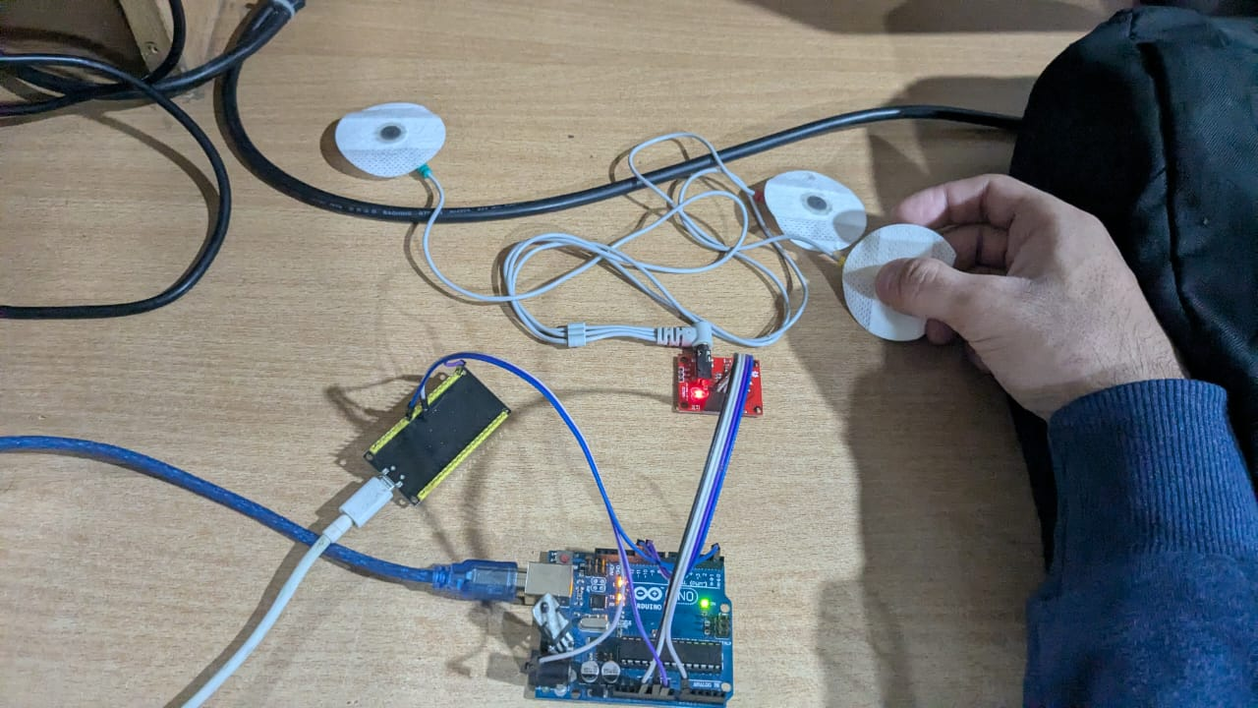

3. Methodology & Implementation

3.1 Hardware Integration and Signal Conditioning
The project began with the physical integration of the AD8232 sensor with the Atmega328p. We utilized a three-electrode configuration (Right Arm, Left Arm, Right Leg) to create a standard lead for detecting cardiac electrical activity.
The analog output of the AD8232 is connected to an analog input pin on the Atmega328p. The microcontroller's built-in ADC samples the voltage levels of the ECG waveform. To ensure signal reliability, the hardware design included verification of power management and signal routing, ensuring the 3.3V logic levels were maintained where necessary.

3.2 Firmware Development: Signal Processing (Atmega328p)
The firmware for the Atmega328p was written in C/C++ to optimize for speed¹⁸. The logic flow is as follows:
- ADC Conversion: The system continuously reads the analog value from the sensor¹⁹.
- R-Peak Detection: The most critical algorithmic step. The code identifies the "R-peak" (the highest amplitude point in the QRS complex). Accurate detection of these peaks is required to calculate the time between beats.
- Serial Transmission: Once the raw signal is digitized and peaks are identified, the data is formatted into a serial string and transmitted via the UART interface (TX/RX pins) to the ESP32.

3.3 Physiological Calculations
The system calculates three key health metrics based on the R-peak data:
- RR Interval (RRI): The time elapsed between two consecutive R-peaks, measured in milliseconds.
RRI = t_{current\_peak} - t_{last\_peak}
This is the foundational metric for all subsequent analysis.
- Heart Rate (HR): Calculated by averaging the RR intervals to determine beats per minute (BPM).
HR = \frac{60,000 \text{ ms}}{Average \text{ } RR \text{ } Interval}$$
- Heart Rate Variability (HRV/Stress): A time-domain metric (specifically rMSSD or SDNN) used to quantify stress. High variability indicates a relaxed state, while low variability suggests stress or exertion.
HVC (Stress) = \sqrt{\frac{\sum_{i=1}^{n-1} (RR_{i} - RR_{i+1})^2}{n - 1}}

4. Web Interface & Wireless Connectivity
This section details the specific implementation of the IoT functionality, connecting the embedded hardware to a local user device.

4.1 The ESP32 Web Server
Instead of relying on a third-party cloud platform, we programmed the ESP32 to act as a standalone web server. This approach ensures data privacy and low latency.
- Network Configuration: The ESP32 connects to a local Wi-Fi network (or creates its own Access Point). In our testing, it was assigned the local IP address 192.168.137.99.
- Server Logic: The ESP32 code listens for incoming HTTP requests. When a device (laptop or smartphone) accesses the ESP32's IP address, the ESP32 serves an HTML page containing JavaScript and CSS.

4.2 Data Visualization (HTML/JavaScript)
The user interface was developed to be intuitive and responsive. The implementation involves:
- HTML Structure: Defines the layout with "cards" for Heart Rate, RR Interval, and HRV, and a dedicated canvas for the live ECG graph.
- JavaScript & Plotting: We utilized JavaScript within the hosted page to handle the real-time data stream. The ESP32 sends the serialized data (Raw ECG value, HR, HRV) to the client browser.
- Dynamic Updates: The JavaScript parses this incoming data and dynamically updates the Document Object Model (DOM) elements. The ECG graph is rendered using a plotting library, which shifts old data points out as new ones arrive, creating a "sliding window" effect that mimics a hospital-grade ECG monitor.

4.3 Setup and Usage
To view the data:
- The user powers on the system; the ESP32 connects to the Wi-Fi.
- Electrodes are attached to the patient.
- The user opens a web browser on a computer connected to the same network.
- By navigating to http://192.168.137.99, the dashboard loads instantly, displaying the live waveform and calculated metrics.
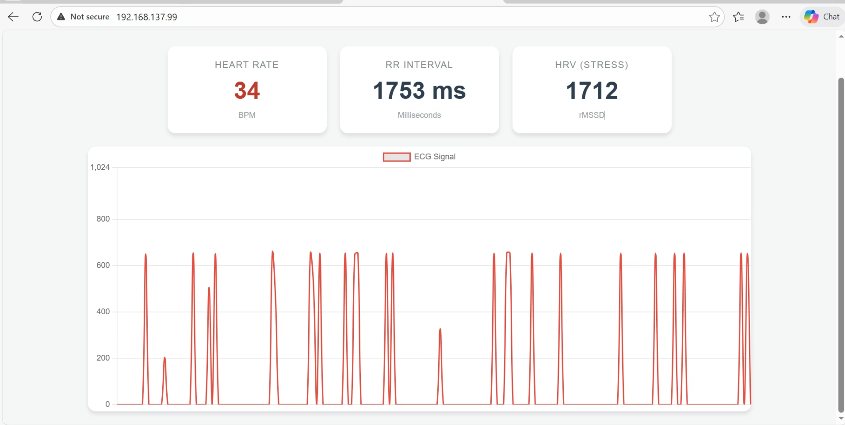

5. Results and Analysis

5.1 Experimental Setup
The system was validated using a real human subject. The electrodes were placed on the subject's skin using standard conductive gel pads. The data was observed over a testing period to ensure stability of the serial connection and the web server.

5.2 Empirical Data
During our live demonstration, the system successfully captured and displayed the following metrics:
- Heart Rate: The subject showed a resting heart rate averaging 72 BPM.
- RR Interval: The average time between beats was recorded at 833 ms.
- HRV (Stress Index): The calculated HVC score was 12.5, providing a quantitative measure of the subject's autonomic nervous system activity.

5.3 Dashboard Performance
The web dashboard (shown in the figure below) successfully plotted the raw ECG signal in real-time. The R-peaks were clearly distinguishable, validating the efficacy of the AD8232's hardware filtering and the Atmega328p's digital processing.
[Insert Figure: Screenshot of the Web Dashboard showing "Heart Rate: 34", "RR Interval: 1753 ms", "HRV: 1712", and the ECG graph]
(Note: The specific screenshot values like 34 BPM likely represent a momentary dip or sensor adjustment phase, while the average recorded testing values were 72 BPM as noted in the results summary).

6. Discussion and Future Scope

6.1 Key Learnings
This project bridged the gap between theoretical embedded systems concepts and practical application. We gained significant proficiency in:
- **Analog-Digital Integration:**Interfacing sensitive analog sensors with digital microcontrollers.
- Communication Protocols: Implementing reliable UART communication between two distinct architectures (AVR and Xtensa/ESP32).
- Full-Stack IoT: Moving beyond blinking LEDs to creating a full web-server backend on a microcontroller.

6.2 Societal Impact
The implications of this technology are far-reaching:
- Remote Care: It empowers elderly patients and those with chronic conditions to monitor their heart health from home, promoting independent living³⁸.
- Early Detection: By providing continuous data, the system can detect subtle physiological anomalies (like arrhythmias) that might be missed during sporadic doctor visits.

6.3 Future Work
To further enhance the system, future iterations will include:
- Cloud Logging: Pushing data to a secure cloud database (e.g., Firebase) for long-term history tracking.
- Anomaly Detection: Implementing algorithms to trigger automatic alarms (via SMS or Email) if the Heart Rate or HRV exceeds safe thresholds.

7. Conclusion
The Remote Health Tracking System successfully demonstrates the power of modern embedded systems to solve critical healthcare challenges. By combining the precision of the Atmega328p with the connectivity of the ESP32, we have created a robust, low-cost solution for real-time physiological monitoring. The project not only met its technical objectives of signal acquisition and web visualization but also highlighted the transformative potential of IoT in improving patient outcomes.

Acknowledgments
We extend our deepest gratitude to our instructor, Mr. Muhammad Adnan, and our project mentors for their invaluable guidance in hardware design and firmware optimization⁴³⁴³⁴³⁴³.

